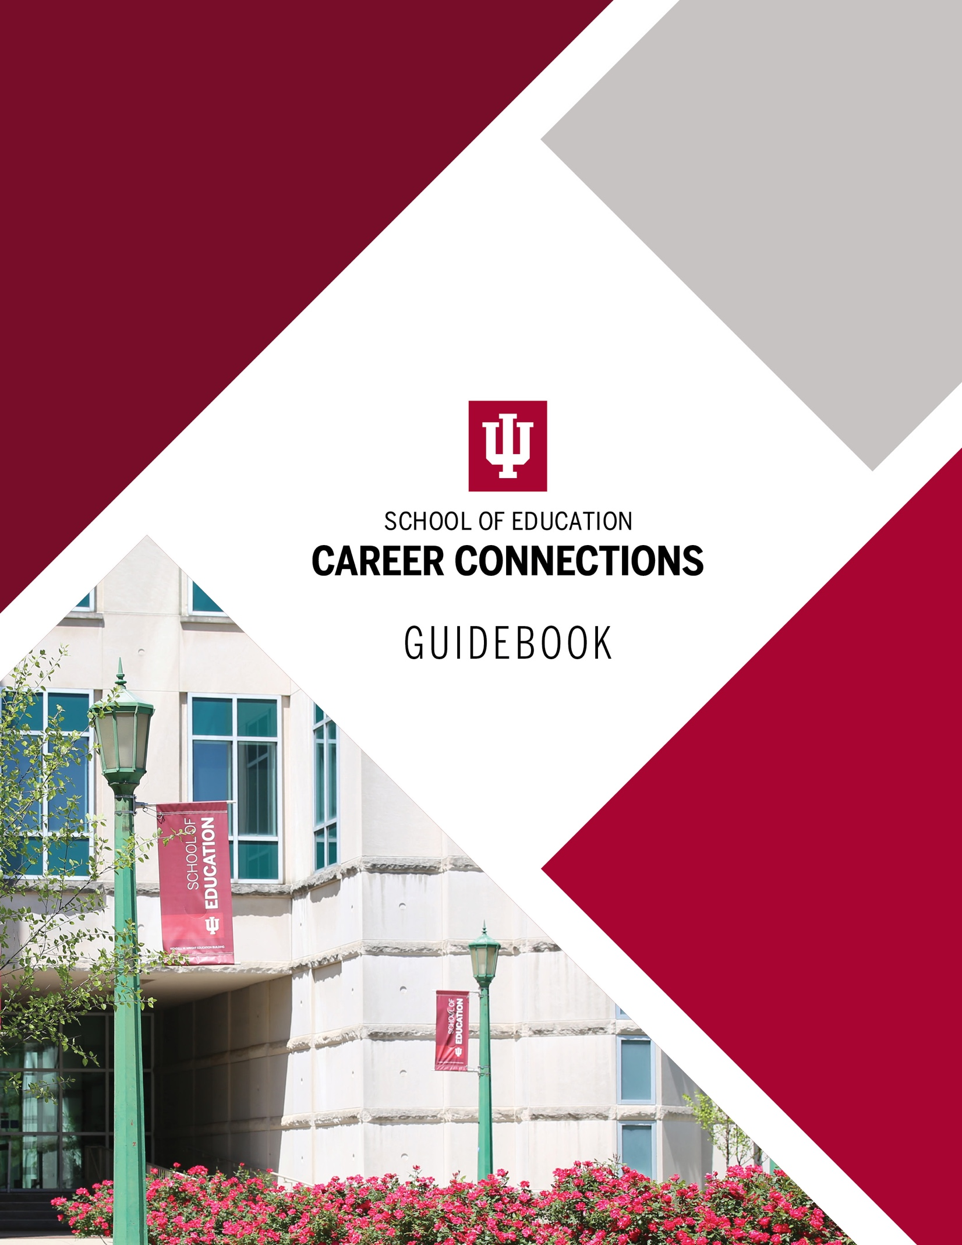

Suite 1000
Undergraduate and Teacher Education
Indiana University Bloomington
edcareer@indiana.edu • (812) 856-8500
https://edcareers.indiana.edu
Instagram @iusoe_career
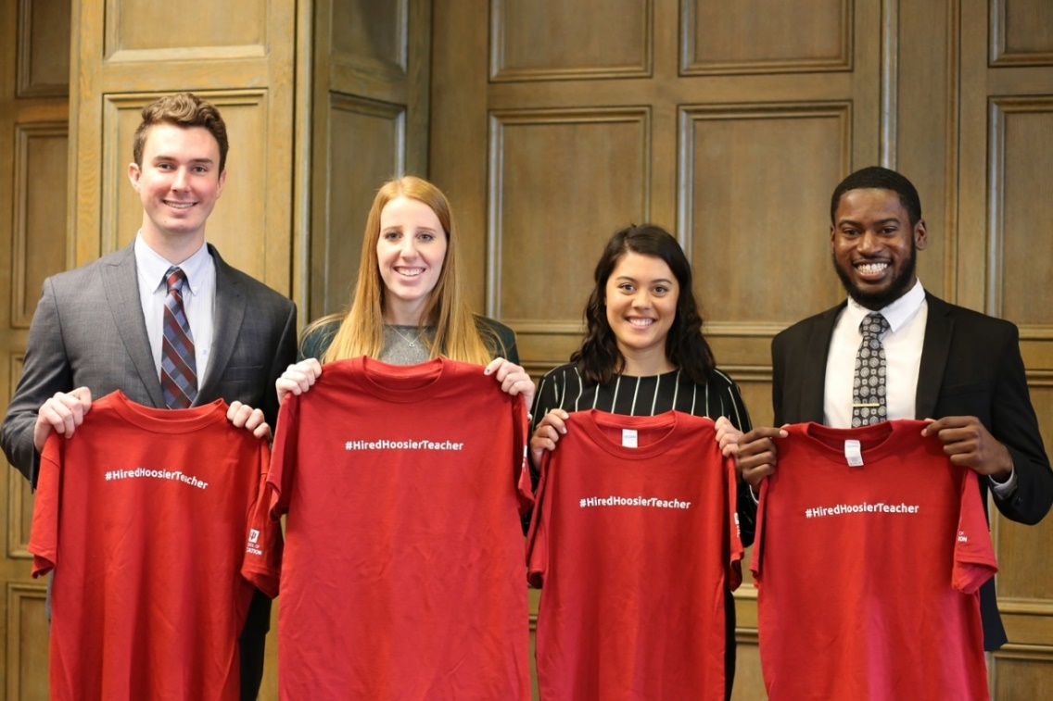

Contents
Our Services 2
Resume Guide 4
Cover Letter Guide 14
Networking 18
Digital Portfolio Guide 21
Interviewing Guide 23
Job Search Resources 33
Accepting an Offer 36
Alumni Employment Surveys 36
Careers Outside the Classroom 37

Our Services

Whether you are just starting your journey or changing your direction, we are here to help you succeed at achieving your professional goals. Our team will work with you to help enrich your professional knowledge, assess the job market, grow your professional network, and transition from college to career.

Career Coaching Appointments
Whether you have questions about resumes, cover letters, interviewing, or other career-related topics, we’re happy to meet with you in-person or virtually. Request a career coaching appointment via Handshake.
- On desktop devices, click Career center on the lefthand menu, then go to Appointments, click Schedule a New Appointment, and choose School of Education Career Connections. Select the most appropriate topic and then choose a day/time from our staff members’ availability.
- On mobile devices, we strongly advise you to download and use the Handshake Jobs and Careers app. to schedule appointments. Choose Account on the bottom menu, then Career Center > Appointments > Schedule a New Appointment, and choose School of Education Career Connections. Select the most appropriate topic and then choose a day/time from our staff members’ availability.

Scheduling tips:
- Access Handshake from your desktop or the mobile app. Trying to schedule an appointment on your mobile device without using the app is not currently working effectively.
- Double check to be sure you are choosing School of Education Career Connections as your career center.
- If a time isn’t available that works with your schedule, email edcareer@indiana.edu to ask about scheduling a time that works for you.
- Get more information about scheduling career coaching appointments in Handshake here: https://support.joinhandshake.com/hc/en-us/articles/219133257-Request-an-Appointment-with-your-Career-Center

Workshops and Events
Attend our many events held throughout the year. We host career-readiness workshops such as the Career Connections Workshop Series, CPR/AED training, and suicide prevention training. Additionally, we host recruiting events, such as Interview Day, the Health and Human Services Career Day, and the Student Teaching Fair. Check the School of Education calendar using the “professional development” filter or Handshake events list with the “soe” label.

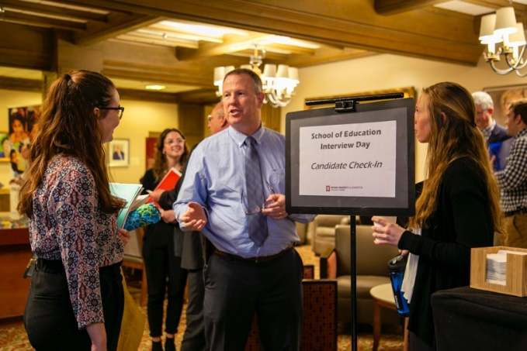
Career Connections Distinctions

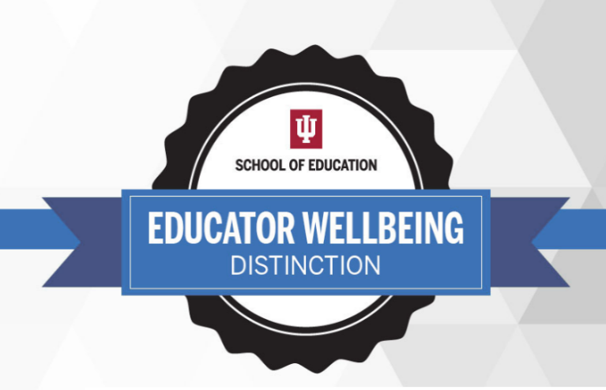
Professional Distinction
Want to get academic credit for investing in your career readiness? Enroll now in our Professional Distinction Courses. Don’t forget to formally register for the distinction program, too, so that Career Connections knows that you want to complete it! After successful completion of just three highly engaging 1-credit courses, you will have enhanced your professional skillset and earned a light-blue cord to wear at commencement.

Educator Wellbeing Distinction
Develop skills that you can use now and for the rest of your life to promote personal wellbeing. Register for the Educator Wellbeing Distinction and successfully complete three interactive 1-credit courses to build skills that will help you remain resilient, hopeful, optimistic, centered, and strong as you pursue your career as an educator. You’ll also earn a light-blue cord to wear at commencement.
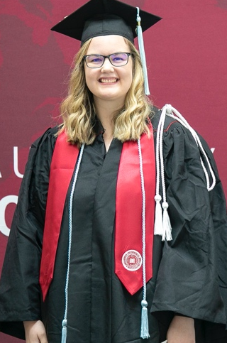

Handshake Job Board
Indiana University has broadly adopted Handshake as its system-wide job board for students. This platform is shared with colleges and universities across the country, and features local, national, and international organizations who are recruiting IU students. Filter by Industry (K-12 Education, for instance) for best results.

Resume Guide

A resume is a job-hunting tool that can help you get an interview, prepare for an interview, and organize information about you for a potential employer. Your resume introduces you on paper. It outlines your education and work-related experiences in an easy-to-read, positive manner and is the “ticket” to get you an interview. Your resume should be attractive, concise, thoughtfully developed and easy to scan quickly.

General Guidelines
- Use perfect, consistent grammar, spelling and punctuation.
- Use present tense for current activities and past tense for previous activities.
- Do not use personal pronouns or articles, e.g. “I”, “me”, “their”, or “the”, “a” or “an.”
- Keep your resume to one or two pages unless you have extensive professional experience.
- Use key words specific to your area of expertise or professional field.
- List your education first if you are still in school or it has been less than 2 years since you graduated.
- List experiences and activities in reverse chronological order; most recent first.
- Focus on accomplishments and not just job responsibilities.
- Start every bullet with an action verb followed by the task you performed and the result, rather than just listing job responsibilities.
- Use bold or italics for job titles and headings.
- Be consistent in format.
- Do not lie or exaggerate. Be prepared to talk about everything on your resume.
- Have several people review your resume for content, style and to ensure it is error-free.
- Customize your resume for each individual employer and position for best results.
- If using a template, carefully select one that best fits your needs; not all templates will be useful.

Sample Resume
The following is a resume example for a candidate seeking a position as an elementary teacher. What makes this resume of high quality? Consider these questions as you examine it:
- What sections are included and in what order?
- Why might that be?
- How is it formatted? Why might that be?
- What is the writing style?
- How are different fonts used to enhance reader
comprehension?
- Where are dates included and in what order?
- What else makes this resume effective?
JORDAN WRIGHT
510 5th Street, Bloomington, IN 47401 | 812-879-5476 | jwright@gmail.com

EDUCATION
Indiana University, Bloomington, IN May 2022
Bachelor of Science in Elementary Education

LICENSURE
Indiana Initial Practitioner License for Elementary Generalist Valid until May 2024

TEACHING EXPERIENCE
Fairview Elementary School, Bloomington, IN Spring 2022
Student Teacher, 3rd Grade
  - Collaborated with a team of general and special education teachers to adapt and modify lessons and activities to meet academic needs of seven students ranging from 2nd through 6th grades
  - Engaged students in assessments to determine academic skill level (Preference, Ecological and Discrepancy)
  - Actively observed transitional admission, review, and dismissal (ARD) meetings and received special mentoring from principal concerning best practices, goals, and procedural guidelines
  - Designed and implemented positive classroom management strategies through consistent application of rules and structure to nurture environment of social awareness, trust, and respect

Riverside School 44, Indianapolis, IN Fall 2021
Field Experience Teacher, 1st Grade
  - Collaborated with host teacher and members of teaching team to plan and implement effective, engaging math lessons for class of nineteen inclusion students
  - Initiated innovative classroom management and community building strategies to enhance positive classroom community
  - Designed and facilitated hands-on science activities that resulted in increased student motivation and participation

University Elementary School, Bloomington, IN Spring 2021
Field Experience Teacher, Kindergarten
  - Developed and instructed individualized reading lessons according to student’s IEP goals
  - Met with parents to gain insight into family experiences with special education
  - Conducted AIMSweb universal screening measures for early literacy skills

Robbins Elementary School, Bloomington, IN Spring 2021
Field Experience Teacher, 5th Grade
  - Assisted diverse student population, including ESL students, to enhance lesson comprehension
  - Engaged students in standards-based social studies unit using project-based pedagogy

RELATED EXPERIENCE
Boys and Girls Club of Bloomington, Bloomington, IN September 2020-May 2022
Reading Tutor, Volunteer
  - Guided elementary aged students with reading fluency and comprehension skills
  - Created engaging activities to meet the students’ learning abilities and needs

Camp Tecumseh YMCA, Brookston, IN June 2019 – July 2021
Counselor
  - Collaborated with co-counselors to plan themes and activities for elementary age children
  - Planned 10-week curriculum for and supervised 10 to 20 nine to thirteen-year-old children
  - Facilitated group activities and outdoor outings for campers

Reed Family, Bloomington, IN January 2019 – June 2021
Caregiver
  - Cared for two boys, ages 2 and 6, five days a week
  - Transported children to their scheduled events and activities
  - Managed family’s daily routine and implemented positive, age-appropriate discipline
  - Guided children in educational activities in accordance to their developmental age

LEADERSHIP, HONORS and ACTIVITIES
Special Olympics of Indiana, Monroe County, Volunteer 2019-2022
Indiana University Education Council, Member 2020-2022
Kappa Delta Pi, President 2020-2021
Community of Teachers Scholarship Fall 2021
Indiana Teacher Association Fall Conference, Presenter Fall 2021

PROFESSIONAL DEVELOPMENT
Attended Armstrong Panel, The Power of Relationships, Indiana University School of Education October 2021
Attended SMARTBoard workshop, Indiana University School of Education April 2021
Attended iPad Apps for Educators workshop, Indiana University School of Education March 2021

CERTIFICATIONS
American Red Cross CPR Certification Valid through 2023
American Red Cross First Aid Certification Valid through 2023

REFERENCES

Susan Brown, 3rd Grade Teacher
Fairview Elementary School
500 W. 7th Street
Bloomington, IN 47404
812-956-7456 sbrown@mccsc.edu

Michael Smith, Principal
Fairview Elementary School
500 W. 7th Street
Bloomington, IN 47404
812-956-7451 msmith@mccsc.edu

David Conner, Professor of Curriculum Studies
Indiana University School of Education
201 N. Rose Avenue
Bloomington, Indiana 47405-1006
812-856-4325 dconner@indiana.edu

Parts of a Resume

- Heading: consists of your name, address, phone number, email address, and website, ePortfolio and/or professional social media accounts.

- Education Experience: list in reverse chronological order (most recent first) the name and location of where you received your degree(s), your graduation year (month/year), and your degree earned. You can also choose to include your major and minor. Listing high school information is not recommended.

- Licensure/Certifications: if you have or soon will have a specific license and/or one or more certification trainings, you should list this after your education information, if the credentials are relevant to the job you are seeking.
  - License: include what state your license is from/for and the type of license you currently hold or are working toward. If you already have your license, provide the month/year that is it valid until (ie. Valid until June 20xx). If you have not yet received your license, be sure to provide the month/year when expected. We recommend using the formal license title (many Indiana license titles for teachers and counselors are provided in the Licensing Titles section, below).
  - Certification: professional skills for which you have completed a training program, such as CPR/AED, First Aid, Suicide Prevention Training, etc.

- Professional Experience: employment, practicum, or internship experiences that are directly related to job for which you are applying. For each experience, list supporting information highlighting what you’ve done (no fewer than 2 bulleted points). Be sure this information is short and specific. Employers are specifically looking for ways that you developed and used knowledge and skills listed in the job description. List experiences in reverse chronological order.
  - Note for Teacher Applicants: list any classroom or education experiences including: previous teaching experiences, substitute teaching positions, student teaching placements, practicum or early field experiences, working at summer camps, etc. and list the dates of your experience.

- Related Experience: any other job or volunteer position that you have held with the dates of your experience. These experiences are related to the job for which you are applying, but not as directly as things listed as “Professional Experience.” Again, list supporting information about your experience (no fewer than 2 bulleted points). List in reverse chronological order.
- Other Work Experience: additional paid positions you have had that you deem important to include on your resume but may not directly relate to the position for which you are applying; highlight transferrable skills that you obtained or demonstrated in these positions.

- Leadership, Activities and Honors: list any activities, clubs, organizations, etc. in which you actively participated and/or that helped you develop leadership skills, as well as honors you have received in reverse chronological order.

- Professional Development: list any professional development opportunities you participated in such as workshops attended, panels attended, related elective courses taken, etc. List these is reverse chronological order. Could come before or after “Leadership, Activities, and Honors” section.

- References: list 3-5 professional references (professors, supervising teachers, past supervisors) and their contact information. Be sure to ask for permission before listing them on your resume. References can be listed on resume or on a separate page.

Teacher Licensing Titles

Indiana licensing titles for initial practitioners:

- Early Childhood (P-3): Initial Practitioner License for Early Childhood Education and Elementary Primary
- Elementary (K-6): Initial Practitioner License for Elementary Generalist
- TAL students (Special Ed and Elementary): Initial Practitioner in Mild Interventions K-6 and Elementary Generalist
- Secondary (5-12): Initial Practitioner in [Content Field] for Junior High, Middle School, and High School
- P-12 (Visual Arts, Physical Education, World Languages, Vocal and General Music, Instrumental and General Music, School Counseling, School Psychology): Initial Practitioner License in [Content Field] for All School Settings

After your initial practitioner license, the next license would be the proficient practitioner license.
- Example: Proficient Practitioner License for Elementary Generalist

Resume Bullet Points

For each experience you list, it is important to go beyond simply stating what you did in that position. Why was the task important? What was your impact within the organization? How did you perform your duties? What skills did you use/develop? What were the results? Use your resume to highlight (but not exaggerate) your accomplishments!

Use formula “Action Verb + Context (What/Who) + Results (Impact)”

Create bullet points that begin with a strong verb, emphasize skills or qualities required in the next job you seek, and conclude with results or gains from the experience.

Examples

Assisted a sixth-grade class with physical science becomes:
- Mentored sixth grade students in physical science, demonstrating ability to develop effective learning relationships with multiple age levels

Planned and taught small group lessons with ELL students becomes:
- Planned and taught small group lessons with ELL students, incorporating cultural knowledge to engage learners

Answered phones for busy office becomes:
- Maintained organized and efficient work environment, answering phones for busy office
  - Note: In this example, the writer leads with the result, then gives context and action.

Attributes Employers are Seeking in New Employees

- Ability to work in a team
- Problem solving skills
- Analytical/quantitative skills
- Verbal communication skills
- Written communication skills
- Initiative
- Leadership
- Technical Skills
- Flexibility/adaptability
- Strong work ethic
- Computer skills
- Interpersonal skills (relates well to others)
- Detail-oriented
- Organizational ability
- Creativity
- Strategic planning skills
- Friendly/outgoing personality
- Entrepreneurial skills/risk-taker
- Tactfulness
- Fluency in a foreign language

Source: Job Outlook 2021 Spring Update, National Association of Colleges and Employers

Action Verbs for Resumes and Cover Letters

Achieved
Acquired
Adapted
Addressed
Administered
Advised
Analyzed
Anticipated
Approved
Arbitrated
Assembled
Assisted
Audited
Balanced
Budgeted
Calculated
Centralized
Changed
Coached
Collaborated
Collected
Communicated
Compared
Compiled
Completed
Composed
Conceived
Condensed
Conducted
Conserved
Constructed
Consulted
Contracted
Controlled
Converted
Coordinated
Created
Cultivated
Defined
Delegated
Delivered
Demonstrated
Designed
Detected
Developed
Devised
Discovered
Doubled
Drafted
Edited
Eliminated
Endorsed
Enforced
Entertained
Established
Evaluated
Executed
Expanded
Expedited
Explained
Facilitated
Finished
Forecasted
Formed
Formulated
Fostered
Founded
Generated
Guided
Handled
Hired
Implemented
Improved
Increased
Influenced

Informed
Inspected
Instituted
Instructed
Insured
Interpreted
Interviewed
Invented
Investigated
Launched
Maintained
Managed
Marketed
Minimized
Motivated
Navigated
Negotiated
Observed
Obtained
Operated
Organized
Originated
Oversaw
Participated
Performed
Persuaded
Pinpointed
Planned
Prescribed
Prevented
Processed
Produced
Programmed
Promoted
Proposed
Protected
Proved
Provided
Publicized
Published
Purchased
Reacted
Recommended
Recorded
Recruited
Reorganized
Reported
Researched
Resolved
Restored
Revamped
Reviewed
Revised
Scheduled
Selected
Separated
Setup
Simplified
Sold
Solicited
Solved
Sorted
Staffed
Streamlined
Structured
Supervise
Supervised
Supplied
Supported
Surveyed
Synthesized
Systematized
Taught
Tested
Trained
Translated
Transmitted
Transported
Traveled
Treated
Utilize

Use this tool to help you develop bullet points for a specific experience listed on your resume!

Experience 1:

Job/Position Responsibilities: list the main different things that you did | Related Action Verbs | Context: who did you serve and what were you doing | Result/Impact: how did the clients or organization benefit | Possible bullet point statement
 |  |  |  | Bullet Point 1:
 |  |  |  | Bullet Point 2:
 |  |  |  | Bullet Point 3:

Experience 2:

Job/Position Responsibilities: list the main different things that you did | Related Action Verbs | Context: who did you serve and what were you doing | Result/Impact: how did the clients or organization benefit | Possible bullet point statement
 |  |  |  | Bullet Point 1:
 |  |  |  | Bullet Point 2:
 |  |  |  | Bullet Point 3:

Cover Letter Guide

General Guidelines
- Writing a cover letter is always easier when you have a specific job posting from which you can build upon. Highlight the most important requirements and qualifications that they are seeking and incorporate them into your narrative.
- In the absence of an available posting or opportunity, consider a proactive approach by submitting a letter of inquiry (discussed below).
- When possible, find an appropriate, specific name to whom you can address your letter; avoid “To Whom It May Concern” whenever possible.
- Make every effort to write a unique, individualized cover letter for each employer and job. Do not recycle the exact same cover letter for each application.
- Be sure to follow up by contacting the organization personally within 2-3 weeks. This is to ensure they have received your materials and it will remind them of your interest in their organization.

Parts of a Cover Letter

Heading
- The same contact information for you that appears on your resume
- Current date
- The employer’s contact information
- A salutation to a specific individual; avoid salutations like “To whom it may concern.”

Introductory Paragraph
- State the intent of your letter. Name the position or type of position you are seeking.
- Capture the reader’s interest in the first few sentences.
- Mention how you heard about the job opening, if applicable.
- Indicate your knowledge of and interest in the organization.

Body Paragraph(s)
- Explain how your career plans, skills, education and/or experiences are relevant to the position and how they coincide with the organization’s needs.
- Highlight your strengths/experience/accomplishments by using specific examples to provide evidence of your qualifications, but always focus on how these qualifications will help the employer achieve their goals.
- Avoid simply restating your resume. Rather, the cover letter is a place to provide a bit more depth and insight into your specific qualifications for the position.

Concluding Paragraph
- State your desire for an interview or other next steps, if that is your intention.
- Express your appreciation for the employer’s time and consideration.
Cover Letter Format

Your Name
Your present street address
City, State Zip Code
Telephone
Email

Date

Contact Person’s Name
Title
School or District
Street Address
City, State, Zip Code

Dear Administrator (or Mr., Ms., or Dr. if you know the person’s name):

First paragraph: State why you are writing. Specify the position for which you are applying and whether you saw an advertisement or heard about the position/school through a referral or by reputation. Work to capture the reader’s interest by identifying something specific that draws you to the position. Briefly preview how you will be an asset to the employer; you will elaborate on this in the body paragraph(s).

Second paragraph: Begin with a sentence that immediately grabs the reader’s attention. Briefly summarize why you are qualified for the position – use examples and specific accomplishments to show how your skills and experience, strengths and accomplishments will address the school’s and the students’ needs. Do not reiterate what is on your resume. However, you can elaborate on something in your resume and how it impacted the students. Highlight any special skills that make you a more valuable candidate, i.e. license additions, specialty areas, a desire to coach a sport, theater/drama experience, interest in music or art, etc. If you are a graduate of the school, student taught or was a TA at the school, mention it in the first sentence of this paragraph.

Third paragraph (optional): Use this paragraph to reveal more of yourself. If you are a career changer, tell how skills developed during your previous experience will be an asset to you as a teacher (i.e. communication, leadership, follow through, organization). You can also state why you decided to teach.

Last paragraph: Express your sincere commitment to education and teaching children. Close the letter with a request for an interview and include your telephone number if you do not use your resume heading. Conclude by thanking the reader.

Sincerely,
(Signature)
Your full name, typed

Source:
School Leader Internship: Developing, Mentoring and Evaluating Your Leadership Experiences (Martin, Wright, Danzig, Flanary & Brown, 2005)

More on Analyzing a Job Posting to Inform Your Cover Letter

Use this chart to help you pull the core information out of a job description, think critically about it, and determine what key things from your own experience you should select to discuss in your cover letter.

Review the Job Description  What key words come up? What are the main tasks you will need to complete? What will you need to be able to do well? | Connect Job Responsibilities to Skills Needed  If you were going to do well in completing the tasks of the job, what skills would you need to have? | Reflect on Your Experience  When have you successfully used the skills listed in column #2? What previous experiences could you discuss in your cover letter that show that you have the necessary skills or are on your way to developing them?
1.

2.

3.

4.

5.

(Adapted from: Resume & Cover Letter Tips for PhD Students. University of Michigan Career Center. https://careercenter.umich.edu/files/cc/umich_resume_and_cover_letter_tips_for_phd_students.pdf , May 12, 2022.)

Sample Cover Letter

STEPHANIE ROBINSON
2900 Purchase Street
Purchase, NY 10577
914-323-0000
robinsons@mville.edu

April 20, 2022

Ms. Sara Jones
Director of Human Resources
Summerville School District
Summerville, NY 11111

Dear Ms. Jones:

I am interested in applying for the elementary teaching position posted on the OLAS website. Your school’s mission of helping diverse students grow as scholars and artists is extremely exciting. The knowledge and skills that I have gained through my Arts Area of Concentration and volunteer work uniquely equip me to support your students’ growth and be an asset to your team.

In addition to completing an undergraduate degree this year, I served as a tutor in an after-school program at a local homeless shelter, where I helped students complete homework assignments and explore academic content through the visual arts and music. Furthermore, as a student teacher, I created lessons that engaged all learners by applying a variety of teaching methods and infusing art, music and technology in my lesson design. I formed cooperative learning groups, organized individualized projects, created learning centers and implemented learning style research in every lesson. Alternative assessment methods, such as portfolios, rubrics and performance assessments, in combination with traditional evaluations, enabled me to assess the students’ academic growth individually and comprehensively. In both my student teaching and tutoring experiences, I met with parents to keep them apprised of their child’s accomplishments and areas of growth. We approached their child’s education as a team.

I am passionate about teaching children and forging relationships with them that help build a sense of confidence and enable them to grow as scholars and artists. I would appreciate the opportunity to meet with you to discuss how my skills and experience can meet the needs of your students. Thank you for your consideration.

Sincerely,
(signature)
Stephanie Robinson

Source:
School Leader Internship: Developing, Mentoring and Evaluating Your Leadership Experiences (Martin, Wright, Danzig, Flanary & Brown, 2005)

Networking

According to Oxford Languages, networking is defined as “the action or process of interacting with others to exchange information and develop professional or social contacts.” Any time you interact with an education professional, you can network and grow the professional community you are a part of. This community can help you learn about resources, strategies, opportunities, etc. that you otherwise would not know about.

Networking Tips
- Attend lectures, workshops, conferences and other events related to education. This is called professional development.
- Attend job fairs, stop by information tables, etc.
  - If appropriate, have polished copies of your resume ready to distribute.
  - If interested, collect business cards or contact information so you can follow up.
- Create a LinkedIn account to help network with others professionally. Connect with professionals you already know and join groups such as the IU School of Education Alumni Network.
- Connect with our alumni using the IU Alumni Directory. Request informational interviews and come prepared with questions about how to successfully transition to the workplace.
- Have your “elevator pitch” ready and use it.
- Say ‘hello’ to people, introduce yourself and keep a list of basic questions in mind to start a conversation with them.
- If you find that you have a mutual interest with someone and want to share resources, have a professional way for them to reach you – business card, online portfolio link, professional email address. Avoid providing your personal contact information.
- Keep your interactions positive; enjoy the opportunity to meet new people and learn about what they are doing in their careers.
- Keep the conversation balanced, ensuring all participants have time to talk.

The Elevator Pitch

An “elevator pitch” is a 30 second introduction to YOU! It is great to have this ready to go, for it is likely your interview will start with a prompt like, “Tell me about yourself.”

Five Components of a Successful Elevator Pitch:
- Who are you?
- What related experience do you have?
- What are your goals?
- Why are your goals important to you?
- How do you plan to reach your goals?

Tips:
- Keep it to 30 seconds!
- Choose your words well. Use action verbs to effectively paint a picture of what kind of professional you are - disciplined, forward-thinking, tech-savvy, responsive, etc.
- List your best accomplishments. Be specific. Don’t try to include everything; you won’t have time.
- Avoid clichés and meaningless fillers. Don’t say you are a team player. Instead, say that you came up with innovative ideas that your math peers used in their classrooms.
- Rehearse your elevator pitch until it doesn’t sound rehearsed. Give friends your elevator speech. Ask them for honest feedback and embrace it.
- Exude confidence. Demonstrate your excitement about meeting this person and your gratitude for this new networking opportunity.

Once you have written your pitch, practice it with a career counselor, friends and/or family members. Use the chart below to help them give you feedback. Practice until it sounds natural; the goal is to have the information solidified in your mind for you to say, but not to make it sound rehearsed.

 | Excellent! | Needs Polishing, but Content is Solid | Needs Substantial Revision
Effective Words
Accomplishments
Filler/Clichés
Natural
Confident

Adapted from: Collins, Dena. “Why Teachers Need an Elevator Pitch: 5 Keys to Your 30-Second Intro.” The AAEE Annual Job Search Handbook for Educators, American Association for Employment in Education, 2021, p. 36.

Letter of Inquiry
In the absence of a specific job posting to apply to, one effective way to indicate your interest in working with an organization is to write a letter of inquiry. This is very similar to a cover letter, but you are reaching out to ask about the possibility of an opening in your area of interest and to generally share your qualifications for such a position.

Sample Letter of Inquiry

Foster Gerard
42 Read Hall
Bloomington, IN 47405

May 17, 2022

Dr. Taylor Jackson
Superintendent of Schools
County School Corporation
2549 Oak Street
Pleasant Valley, IN 47123

Dear Dr. Jackson:

I am writing to inquire into the availability of an elementary teaching position in your corporation. As a new teacher, I am excited about the opportunity to begin my career in a school system such as yours. I particularly like what the system is doing with curriculum revision and “Teachers Teaching Teachers.” The type of challenge and support provided by these programs creates a positive school environment. For these reasons, I would like to be considered for an elementary opening at County School Corporation.

My Bachelor of Science in Elementary Education was conferred this May by Indiana University. I also have a reading specialist certificate and anticipate my Initial Practitioner License for Elementary Primary and Intermediate in June 2022. I would like to be able to organize my classroom much like the high energy environment I created in my student teaching experience with Mrs. Planner at Cherry Elementary School. The satisfaction I received from facilitating the growth and development of those young people reaffirmed my desire to be a classroom teacher. A most valuable part of this experience was the opportunity to be involved in the “TESA” (Teacher Expectation Student Achievement) training that took place at Cherry during (and after) my time there.

Through these and other experiences in which I participated throughout my college career, I have gained valuable knowledge that will assist me in becoming an effective educator. Included is my resume which provides additional information regarding my professional preparation and experiences. Thank you for your consideration.

Sincerely,
(signature)
Foster Gerard

Digital Portfolio Guide

General Guidelines

Digital Portfolios can be quite useful in your job search. These electronic “scrapbooks”:

- Provide a deeper, more vivid glimpse into you as an education professional.
- Are easy to access (unlike the bulky hard-copy portfolios common decades ago).
- Allow employers to learn more about you long after your interview is over.
- Can be the extra edge you need to land the job of your choice.
- Can be updated throughout your career to document what you’ve accomplished and share that with parents, colleagues, and administrators.

What to Include

Include things that you think show your accomplishments, skills, and perspective as a teacher. Be sure to at least include:
- A Home or About Me page
  - Welcome paragraph and a professional picture of you
- Your resume
- Your teaching philosophy
  - No more than a page, grammatically perfect and entirely your own
- Sample annotated lesson plans
  - Short versions of your most successful lessons
  - For self-created material, include a Creative Commons license at the bottom
- Photos of you teaching, your classroom, student work examples, results of units of study or committee work that you have been a part of
  - Video content is also useful
  - Be sure you always have permission to use photos of students and/or student work
  - Use short captions to give context to the work that you feature, highlight what you and/or your students learned, and explain why you have chosen to include this item
- Links to your professional social media profiles
  - Do not list any profile that is not current and strictly professional

Tools for Portfolio Building

- Blog
- Wordpress, Blogger, EduBlogs
- Good for updates and stories
- Works well for established teachers
- Website creation tools
- SnapPages, GoogleSites, Weebly
- Professional Looking
- Great way to highlight content and resources
- Digital Mediums
- LiveBinders, Portfoliogen, Shutterfly
- Easy to organize
- Less time worrying about widgets and flare
- Lower Tech
- Flash drive with files saved on it in organized and clearly labeled fashion
- Have several of these to leave with your interviewers

Other Considerations

- Choose a URL that’s easy to remember; preferably with your name
- Templates can be great tools, and custom banners can also personalize your site
- Use bright and clean color schemes
- You must have the legal rights for every image you use

Your Digital Presence

Mediums like LinkedIn or Twitter can be great ways to establish your professional presence and network with other professionals. Employers can also glean a lot of information about you from what you post online, both socially and professionally. Here are things to consider as you work to cultivate a professional digital footprint.

- Google yourself.
  - If parents, students, coworkers, and employers see what you see, are they getting the impression of you that you want them to have?
- Look critically at your professional website.
  - Is it updated? Does it align with your resume? If you have more than one, do they have the same information?
- Use digital tools, like Instagram or Twitter, to build a personal learning network (PLN).
  - When an employer looks at your feed, what will they learn about you as a professional?
- Assess your resume.
  - Have you put links to all your professional accounts on your resume?
  - You control the content of these accounts, so they can be a great way to showcase your professionalism.

Source: Marotta, Cassie. “An Educator’s Digital Presence”.
The AAEE Annual Job Search Handbook for Educators, American Association for Employment in Education, 2021, p. 36.

Interviewing Guide

General Guidelines

- An interview is an opportunity for an employer to develop a deeper understanding of your professional background, accomplishments, goals and level of confidence.
- Come to your interview with 5-7 specific, concise examples in mind from your professional experiences that will help you craft specific, focused, experience-based answers to the interviewers’ questions. Keep your stories accomplishment and results focused.
- It is also YOUR opportunity to get to know the employer better by researching the employer and job, meeting some of the people with whom you will work and asking some questions about the position and employer.
- Taking time to prepare for an interview is a must! The Interview Checklist below will help you do this!

Source: The AAEE Annual Job Search Handbook for Educators. American Association for Employment in Education, 2021.

What are employers seeking/not seeking?

Employers want to see: | Employers do NOT want to see:
- Professional-field knowledge  - Knowledge/skill regarding DEI  - Passion and enthusiasm  - Ability to use technology  - Willingness to learn and grow  - Excellent communication skills  - Ability to work in a team  - Positive attitude  - Reliability  - Confidence and professionalism  - Willingness to get involved  - Effective problem-solving skills  - Specifically, for teachers:  - Content knowledge  - Classroom management skills  - Knowledge of standards  - Ability to differentiate instruction  - Creativity in lesson development  - Knowledge of special education  - Ability to use varied assessments | - Tardiness  - Inappropriate language or dress  - Lack of eye contact  - Sharing too much personal info  - Negativity about past experiences  - Exaggerating or lying  - Lack of energy  - Lack of knowledge  - Inability to explain why applying  - Lack of depth in responses  - Inability to answer questions  - Being over-confident/arrogant  - Self-centeredness  - Inattention, lack of focus  - Overly general information not related to specific position

Generating Specific Examples to Share in Interview

As you prepare for your interview, it is a good idea to think about the specific knowledge and skills a particular employer is seeking and examples of times when you effectively used those skills or knowledge. Going into the interview with these examples in mind can help you efficiently provide specific, concise examples from your experience when answering relevant questions. If you are going to answer a question with a specific example from your experience, keep your response brief and focused with the S.T.A.R. format:
- Situation you were in.
- Task you were asked to accomplish or the challenge you were presented with.
- Action that you took to complete the task or address the challenge.
- Result or ultimate outcome of the action that you took.

The process for generating each example:

Questions You May Be Asked in an Interview

There are four main types of questions you may be asked in an interview.

- Technical: What is your technical knowledge? What do you know about a particular methodology, technical system, topic, etc.?
- Situational: How would you behave in a hypothetical future situation? What would you do if…?
- Behavioral: In the past, how have you applied your skills in particular situations. Tell me about a time when you…”
- Off-the-Wall: How do you think outside the box? If you were a tree, what type of tree would you be?

Below are some of these various types of interview questions. Practice answering these questions with career services staff, in front of the mirror, with a friend or with a family member. Remember, when discussing past experiences, keep your answers focused by using the STAR format.

Interview Questions for Prospective Teachers:

Getting to Know You
- Tell us about yourself.
- What circumstances led you to enter the profession of teaching?
- What do you hope to be doing in 5 years? What are your career goals?

Interpersonal Skill
- If I talked to your students/principal/supervising teacher/etc., what three words would they use to describe you?
- How would you support and sustain collaboration between home and school?
- If confronted by an angry parent or colleague, how would you respond?

Instruction
- Tell me about a time when you developed and taught an especially successful standards-based lesson. Walk me though all the steps of planning, delivery and assessment.
- How do you meet the range of skill-level and needs commonly present in a classroom?
- What kinds of techniques do you use to stimulate active participation in the classroom?

Assessment
- How do you know students are learning what you are teaching?
- How do you measure student success?
- How do you know if your curriculum or approach appropriately meets your students’ academic and developmental needs?

Classroom Management
- What are some characteristics of a well-managed classroom?
- Tell me about a time when you faced a difficult discipline situation and how you handled it.
- If you were having struggles with classroom management, who would you ask for help and at what point?

Self-Analysis
- What was one of the most significant challenges you faced during student teaching?
- If you were using a teaching method that you knew was effective for student learning and your principal told you to stop, what would you do?
- Describe a challenge you experienced in student teaching and what you learned from it.

Closing Questions
- What new ideas might you bring to our school?
- What extracurricular activities can you supervise?
- Do you have any questions for us?

Adapted from: Kersten, Thomas. “Commonly Asked Interview Questions.” The AAEE Annual Job Search Handbook for Educators, American Association for Employment in Education, 2021, p. 48.

Common Interview Questions for Non-teaching Fields:

Getting to Know You:

- Tell me about yourself.
- What do you know about our organization? Why do you want to work for us?
- What technical skills and/or knowledge do you have that fit this position?
- Where do you see yourself five years from now? What are your future goals?

Teamwork Questions:

- Describe how you contributed to the success of a team of which you were a member.
- Describe a situation where others you were working with on a project disagreed with your ideas. What did you do and what was the outcome?
- Tell me about a time when you effectively demonstrated leadership.

Customer Service Questions:

- Describe a time when you provided excellent customer service.
- Tell me about a time when you engaged with a dissatisfied customer and the outcome was positive. What steps did you take to reach that positive outcome?

Adaptability Questions:

- Give an example of a time when the scope or structure of a project changed. How did you modify your plans/actions? What was the outcome?
- Describe a time in which you had to adjust quickly to changes over which you had no control. What was the impact of the change on you? On your work or project?
- Give an example of a time when you had two important projects competing for your time. How did you handle? What happened?

Time Management Questions:

- Describe a situation that required you to handle multiple tasks at one time. What did you do?
- What is your procedure for keeping track of items that need your attention?

Communication Questions:

- Give an example of a time when you communicated successfully with another person, even when that individual may not have agreed with your point of view.
- Listening is a valuable tool. Describe a time when good listening skills helped you overcome a communication problem or gave you an opportunity to exceed a customer’s or coworker’s expectations.
- Tell me about a situation when you had to speak up (be assertive) in order to get a point across that was important to you.

Motivation Questions:

- Describe your ideal supervisor.
- What challenges are you looking for in a position?
- What work experience has been most valuable to you and why?

Questions to Ask Your Interviewers

Below are some examples of the types of questions you can ask during your interview.

Common for Prospective Teachers:

- Tell me more about the students who attend this school and the culture of the school.
- What is a typical class load for someone in this position?
- What types of school activities promote parent-teacher-student interaction?
- How does this district promote staff development activities and conferences? What types of programs have the teachers attended in the last year?
- What support or mentorship programs do you have in place for new teachers?
- What discipline procedures does the district use?
- Do your schools use cadet teachers, community volunteers or parent volunteers?
- What technology resources will be available to me in the classroom?

Common for Non-teaching Fields:

- What are the specific responsibilities or projects assigned to a person in this position?
- How is job performance in this role evaluated?
- What kind of supervision or mentorship is provided to a person in this position?
- What are some of this organization’s short and long-term goals?
- How would you describe the culture of this organization?
- What professional development opportunities do you offer to your employees?
- What skill set do you think the ideal candidate for this position will have?
- What are the next steps in the hiring process?

Inappropriate Interview Questions
What would you do if you were asked an inappropriate interview question? This rarely happens, but if it does, you don’t want to react in a way that casts you in an unprofessional light. Thinking through how you would want to professionally respond is much easier to do in advance than during the interview itself. This section will help you do that.

Questions will occasionally (& sometimes inadvertently) come up in interviews that are inappropriate, or even illegal for a potential employer to ask. In general, if the question is not related to the job for which you are applying, it is not appropriate for the interview. The chart below distinguishes between some permissible and impermissible questions about a variety of topics.

Topic | Permissible | Impermissible or Questionable
Name | Is any additional information relative to change of name, use of an assumed name or nickname necessary to enable a check on your work and educational record? | Any inquiries about a name which would indicate your lineage, ancestry, national origin or descent, or marital status; inquiries into previous name of applicant where it has been changed by court order, marriage or otherwise. Inquiry if a woman is Miss or Mrs.
Photograph | May be required after hiring for identification | Require or request photo before hiring, or attached to application
Address | Questions about place and length of current and previous addresses; “How long have you lived here in Indiana/Bloomington” | Questions about foreign addresses which would indicate national origin; names and relationships of people you live with; whether you own or rent a home
Race,  Ancestry, or National Origin | Languages you read, speak or write fluently | Inquiries into your lineage, ancestry, national origin, descent, birthplace or native tongue. National origin of your parents or spouse.
Citizenship | “Do you have the legal right to remain permanently in the U.S.?” | “Of what country are you a citizen?” Whether you or your parents or spouse are naturalized or native-born US citizens, or when any relative acquired U.S. citizenship.
Marital & Family Status | Whether you can meet specified work schedules or if you have activities, commitments or responsibilities that may hinder the meeting of work attendance requirements. Questions about duration of stay on the job or anticipated absences which are made to applicants of all genders. | Any questions about whether an applicant is married, single, divorced, engaged, etc. Number and ages of children, questions about pregnancy, sexual orientation or child care arrangements.
Accessibility | Whether you have any accessibility needs – sensory, mental or physical, which may affect work performance on the particular job in question, or which the employer should consider in determining job placement | General inquiries would require applicants to divulge accessibility needs or health conditions which do not relate reasonably to fitness to perform the job.
Religion | Whether or not you are able to work normal hours and days required by the job to avoid possible conflicts with religious or other personal convictions | Your religious denomination or affiliation, church, parish, pastor, synagogue, mosque, or religious holidays observed. Any inquiry to indicate or identify religion or customs.
Military Record | Type of education and experience in service | Type of discharge

How to Respond to Illegal or Inappropriate Interview Questions

What constitutes an appropriate response depends entirely on the interviewee, their perception of the situation, and their willingness to answer the question. When you are asked a question that you sense is illegal or inappropriate, you have options:
- Answer the question based on your understanding of the question’s intent (getting to know you, connecting with you due to a common birthplace, etc.).
- Question the relevance of the question by asking how it is relevant to the job responsibilities. You also could change the subject by focusing on something job related. Finally, you could politely let the interviewer know that their question appears to be discriminatory and excuse yourself from the interview.
- Side-step the question and redirect the conversation to job-related concerns. Here are some examples of how to do this.

Gender:
- Question: How would you handle managing a team of all men?
- Answer: I’m very comfortable in a management role. In fact, in my last position, the department I led exceeded its annual sales goals for three years straight.

Marital or Family Status:
- Question: When are you planning to get married and have children?
- Answer: You know, I’m not quite there yet. But I am very interested in the career paths you have to offer. Can you tell me more about that?

Citizenship, Nationality, or Language:
- Question: I notice you have an accent? What is your first language? Where were you born?
- Answer: I live in Indiana. I can assure you that I am legally allowed to work in the U.S.

Age:
- Question: When were you born? How old are you?
- Answer: My education at Indiana University has equipped me with extensive knowledge and skills. Among the qualities I bring to your school are...

Religion:
- Question: What is your religious background?
- Answer: That is an interesting question. I assure you that there are no factors in my personal life that will prevent me from completing my professional responsibilities to you.

Sources:
- https://ocs.yale.edu/channels/illegal-interview-questions/
- “What should I do if I am asked an illegal interview question?” The AAEE Annual Job Search Handbook for Educators, American Association for Employment in Education, 2021, p.53.
- https://www.forbes.com/sites/dailymuse/2012/04/20/5-illegal-interview-questions-and-how-to-dodge-them/#499edac6191f

Post-Interview Thank You Tips

1. Is a “Thank-You” letter necessary after a job interview?
Absolutely! A thank-you note demonstrates your appreciation for the time the interviewer spent with you. It also shows professional etiquette, provides a space to reiterate your qualifications and will make you stand out.

2. Should the letter be handwritten?
Do what works for you! Handwritten letters feel more personal, while business-style letters or email show professionalism and can provide more space for showcasing your qualifications and written communication skills. Take an approach that allows you to send the letter within 24 hours of the interview.

3. What should be included in a thank-you letter?
- A salutation to a specific person; write a separate note to each interviewer
- Say thank you and show appreciation
- Include specific, positive information about the interview
- Could also:
  - Say something unique you learned about the school
  - Provide supplementary information about your qualifications
- Restate interest and availability
- Invite continued communication
- NO TYPOS! (check spelling of interviewer's name)

Sample Thank You Note

1002 W. Roosevelt St.
Bloomington, IN 47406

May 21, 2022

Mr. Moller
2743 Right Road Rm 223
Louisville, KY 57512
Dear Mr. Moller:

Thank you for the opportunity to interview for the ENL teacher position at Apple Square School. Visiting your school reaffirmed my interest in the position and confirmed my confidence in my ability to excel, should I be selected.

The job, as you presented it, seems to be a very good match for my skills and interests. My experience working with underserved, new language learners, my classroom management skills and my work ethic will serve your school well. Additionally, the high expectations you hold for your students and staff assure me that the position will be challenging and rewarding, allowing me to grow professionally.

Once again, I would like to express my interest in the ENL position. I look forward to hearing from you soon. I can be reached at (812) 333-3333. Thank you very much for your time.

Sincerely,
(Signature)
Mary Ann Abner
Interview Checklist

Before the Interview
- Write down the time/place of the interview and
the name of the interviewer/s.
- Preview the route, check out parking, entrances
and check-in points.
- Review your resume and portfolio (be prepared to answer questions about any topics in them).
- Research the organization (search for information
online, check out applicable websites, pinpoint the location).
- Prepare questions for the interviewer(s).
- Practice answering sample interview questions with a friend, family member or Career Connections advisor (see Interview Questions to Answer and Ask).
- Prepare a special interview folder to take along. Include extra copies of your resume and references page, paper/pen for writing notes, business cards, etc.
- Get plenty of sleep and eat an adequate breakfast.
- Take your time getting ready and save time to relax before the interview.
- Leave early and arrive at least 10 minutes before the interview time
- Bring only the interview folder, access to your portfolio and a professional handbag/briefcase.
- Remember that your interview begins as soon as you arrive on site.

A Note on Dressing for the Interview
Style of dress is a subjective area where you will have to make some decisions. While there are some generally accepted guidelines, you will ultimately need to select an outfit that you are comfortable in, projects your teacher identity, and is appropriate for the culture of the corporation to which you are applying. Below are some suggestions.

- Dress professionally; being overdressed is preferable to being underdressed.
- Keep jewelry simple; don't let your jewelry create a distraction from your words.
- Hair should be neatly styled.
- Avoid perfume or cologne; some people are very sensitive to scents.
- Overall appearance should be clean and neat, with special attention to breath, fingernails and other areas of personal hygiene.
- Allow your appearance to project how seriously you take this opportunity.

During the Interview
- Communicate your interest and enthusiasm to the interviewer(s). Give a warm greeting and smile! Use your discretion regarding exchanging handshakes.
- Be sincere and direct. Be yourself. Stay positive.
- Be aware of your non-verbal behavior (eye contact, posture, clear speaking).
- Answer specific questions specifically; the STAR format (see below) can help. Use real experiences as examples for interview questions
- Don’t ask about pay, benefits or vacation time. You can research this information on the district’s website beforehand.
- Offer information that promotes confidence in your ability to handle the job.
- Answer questions in a focused way; don’t continue talking out of nervousness. Feel free to follow a response with a polite “Does that answer your question?” Feel free to clarify a question (“Let me summarize what you are asking... Is that correct?) or to ask to come back to a question (“That’s a great question, and I’d like to think about it. Can we come back to it?)
- At the close, make sure you are aware of the next steps in the selection process, including when you can expect to hear a decision.
- If you are interested in the job, reiterate this fact and thank the interviewer(s) for their time and consideration.
- Always leave a good impression, even if you don’t think you’ll be offered the job or you’ve discovered that the job is not the best fit for you. A good reputation can open doors that you don’t know exist.

After the Interview
- Write a simple thank you note to each interviewer and deliver, mail or email within 24 hours of the interview. Call a secretary or office assistant if you need to confirm the address or the correct spelling of names.
- Follow up with ONE phone call if appropriate.

Job Search Resources

Remember that Handshake is the number one place to find employers recruiting IU students for part-time and full-time/professional jobs. Filter by Industry (K-12 Education, for instance) for best results.
When reviewing job postings, always use caution and common sense. Fraudulent individuals will use job boards to steal identity data and/or money from unsuspecting applicants. Please review common job scams and how to protect yourself at https://studentemployment.cdc.indiana.edu/part-time-jobs/fraudulent-jobs.html.

If an opportunity looks too good to be true, it often is. If ever in doubt, contact us. Please use discretion as you browse the additional resources below.

More Job Search Resources for Teachers:

- Go to the website for the specific school district in which you want to work; look for a link to employment information; open positions should be posted there
- Search for Indiana teacher vacancies in the IDOE School Personnel Job Bank (Nimble)
- Find contact information for state departments of education here: https://www2.ed.gov/about/contacts/state/index.html
- If applicable, check out Nemnet, a national Diversity & Consulting Firm seeking to connect job seekers to employment in education; https://www.nemnet.com/Index.aspx
- General search engines, like Indeed or ZipRecruiter, could give you leads, but generally are not as useful or reliable as the postings coming directly from school districts or state departments of education. If you see something interesting on one of these general search engines, go to the organization’s website, look for the position there, and apply directly through the school district.

More General Job Search Resources:

- Go to the website for the specific organization where you want to work; look for a link to employment information; open positions should be posted there
- Indeed.com – an international job board that regularly advertises over 33 million job postings
- LinkedIn Jobs – will recommend jobs based on your profile
- Idealist.org—for people who “want to make a career out of doing good”
- GuideStar—find organizational information for nonprofits around the country

Job Search Resources for Those Seeking International Employment

Be sure to check out the IU Office of Overseas Studies; here you can find internships, teaching abroad, and other work opportunities.

The American Association for Employment in Education’s AAEE 2021 Job Search Handbook for Educators included many resources for teaching abroad:
- Council on International Educational Exchange: www.ciee.org/teach
- Department of Defense Education Activity: https://www.dodea.edu/Offices/HR/index.cfm
- Dipont Education: www.dipont.com
- GoinGlobal: http://www.goinglobal.com/
- International Schools Services: www.iss.edu
- JET: Japan Exchange and Teaching Program: http://jetprogramme.org/en/
- Peace Corps: www.peacecorps.gov
- U.S. Department of State—Office of Overseas Schools: www.state.gov/m/a/os
- TESOL International Organization: www.tesol.org
- TIE Online: www.tieonline.com
- Time Plan: www.timeplan.com
- Transitions Abroad: www.transitionsabroad.com
- University of Northern Iowa Overseas Placement Service for Educators: teachoverseas.uni.edu
- World Teach: www.worldteach.org

Keep your job search organized!

Use the following tool to keep the job search details organized, as you conduct your job search. This will help to ensure that you don’t miss an opportunity to submit an application, follow-up, send a thank you email. It also can be a huge time saver!

Job Search Spreadsheet:

Name of organization | Website & Contact Person(s) (w/contact info.) | Location/ distance from where you plan to live | Attractive features of the job/ organization | Contract/Min. Starting Wage | Mission Statement | Application Date | Inter-view Date | Thank You Note Date | Follow-up Date | Offer?

Accepting an Offer

Think carefully if you have more than one offer. Your decision will impact your life dramatically for the next year or more. Reneging on an offer after accepting one is unprofessional behavior. It is important to fulfil your commitment, especially if you have signed a teaching contract. As you consider whether or not to accept a particular position, it can be helpful to create a chart that helps you assess how the position aligns with your different priorities when it comes to employment. Here is an example, inspired by School of Education alumni Dr. Blair Baker’s presentation It’s Okay to Look Back:

 | Job #1 | Job #2 | Job #3 | Job #4
Will it provide income to meet my basic needs?
Does it allow me to enjoy aspects of life that are outside of work but important to me?
Does it allow me to grow professionally?
Does it allow me to develop skills that can help me meet non-professional goals that I have?

Notify Career Connections (edcareer@indiana.edu; 812-856-8506) that you accepted a job! This will stop us and our employer partners from contacting you about future employment opportunities.

Alumni Employment Surveys

After graduation, you can expect to receive at least one graduate employment survey from Career Connections. As is common practice with all IU Schools, Career Connections is tasked with collecting “first-destination data” from recent graduates. Your individual responses are never shared with anyone outside the Career Services Council Metrics Committee. We typically survey recent grads from August-January, and you’ll receive periodic emails until the survey is completed. After the survey closes, we will do a random drawing for 20 lucky respondents to receive $20 Target gift cards.

If you received a Bachelor’s in Education degree, we will survey you again two years after graduation, and will share your responses with faculty and administration in order to help inform the SoE curriculum and to satisfy our accreditation requirements. Again, 20 respondents will receive $20 Target gift cards.

You can see the results of these surveys at https://education.indiana.edu/about/measures-of-success/index.html. Thank you for your time and hard work!

Careers Outside the Classroom

With a degree in education, there is no limit to the direction your career path may take!

Education students who are interested in opportunities outside the classroom often explore careers in:
- Nonprofit, Health, and Social Work: Patient Advocate, Behavior Technician, Case Management, Grant Writing
- Higher Education: Academic Advisor, Career Coach, Residential Staff, Recruitment, Adjunct Teaching
- School Counseling
- Education Psychology
- Museums
- Camps and Outdoor Recreation
- Corporate Training

Teachers with a few years of experience have even more options:
- K-12 Leadership: Instructional Coach, Director of Curriculum, Principal, Athletic Director, Superintendent
- Instructional Technology
- Education Publishing
- Education Policy
- Education Research
- Education Consulting

Interested in continuing your education? See all the School of Education’s graduate programs at https://education.indiana.edu/programs/graduate/index.html.

